C3PR v2

Installation Guide

caBIG™ is an initiative of the National Cancer Institute, NIH, DHHS
Development Team(s)
Development | Installation Documentation | Program Management
Kruttik Aggarwal² | Priyatam Mudivarti² | Bob Annechiarico¹
Manav Kher² |  | Jamie Cuticchia¹
Priyatam Mudivarti² |  | Patrick McConnell¹
Ram Chilukuri² |  | Ram Chilukuri²
Ramakrishna Gundala²
¹Duke Comprehensive Cancer Center | ²SemanticBits
Table of Contents

Introduction 1
Support for C3PRv1 1
Overview of C3PRv2 1
C3PR Software and Technology Requirements 2
Hardware Requirements 2
Software Requirements 2
Required Software 2
Optional Software 3
Installing the C3PR 5
Preliminary Considerations 5
Downloading C3PR, Configuration 5
Setup Database 6
Configure data source properties for C3PR 6
Create Tables 7
Populate Static Data 7
Build / Deploy Code (Ant) 8
Setup Web Server, Configuration 8
Configure log4j 9
Configure Dorian / Web SSO configuration 9
Configure ESB Broadcast feature 9
Configure ESB connection factory 10
Configure Globus 10
Disable/Enable Login Screen 10
Running C3PR 11
Summary of C3PR Components 12
Contacting Technical Support 12
Appendix - CVS 13
Setup Tortoise CVS client 13
Setup Eclipse CVS Perspective 18

Introduction
This installation guide outlines the supported configurations and installing, setting up and configuring the application and databases for C3PRv2. All of the steps and screenshots included in this guide are Windows/Linux specific. If you are using a different platform, then modify the information as appropriate for your system.

Support for C3PRv1 | Although C3PRv2 is based on the underlying functionality of C3PRv1, much of C3PRv2 has been redesigned with more accepted open source technologies to meet the current standards for interoperability and web application development in alignment with caBig initiative. Hence we are not supporting C3PRv1 as a part of C3PRv2 development, however critical functionality, use cases would be reused/refactored into C3PRv2, wherever possible.

Overview of C3PRv2 | C3PR is a central participant registry and underlying database that will allow the management of patient clinical trials registration information and protocol information across studies, sites, systems and organizations.  C3PR operates on its own data tables for Patient, Study and Registration Data. The implementation of the system will preserve the fundamental independence of the storage of the patient and registration information from the scientific and research data. System identifiers will be used to relate patient demographics and identifying information to eligibility, medical or treatment data.

C3PR Software and Technology Requirements

Hardware Requirements
There aren’t any stringent hardware requirements as C3PR is a lightweight web application, not intended to have a very large code base.
Processor | Pentium PIII, above 1.5 GHz
RAM | Minimum 512MB. (testing)  2 GB recommended
Operating System | Windows 2k,XP/Linux Server
Hard Disk Space | Minimum 1 GB free space

Software Requirements
Required Software | You must download and install the required software that is not included with the C3PRv2 (listed in Table 1 ) The software name, version, description, and URL hyperlinks (for download) are indicated in the table

Software Name | Version | Description | URL
Java Software Development Kit (SDK):Java 2 Standard Edition (J2SE) | JDK 5.0 Update 11 or higher | The J2SE Software Development Kit (SDK) supports creating J2SE applications | http://java.sun.com/javase/downloads/index_jdk5.jsp
Oracle 9i/10g Database | 9i/10g | Oracle is a commercially-available relational database management system (RDBMS) that can be used on all major operating systems | http://www.oracle.com/technology/software/products/database/oracle10g/index.html
PostGreSQL | 8.2 | PostgreSQL is a powerful, open source relational database system. It has more than 15 years of active development and a proven architecture that has earned it a strong reputation for reliability, data integrity, and correctness. It runs on all major operating systems | http://www.postgresql.org/ftp/source/v8.2/
Tomcat Web Server | 5.5.20 |  | http://tomcat.apache.org/download-55.cgi#5.5.20
Ant | 1.6.5 | Ant is used for Building the C3PR application | http://archive.apache.org/dist/ant/binaries/
Internet Explorer/Mozilla Firefox Browser | 6.0/2.0 | Default browser(s) for C3PR webapplication. Currently we have not tested for IE 7.0
Maven* | 2.0.5 | Maven is used to build ServiceMix project within C3PR | http://www.apache.org/dyn/closer.cgi/maven/binaries/maven-2.0.5-bin.zip
ServiceMix* | 3.1 | Apache ServiceMix is an Open Source ESB (Enterprise Service Bus) that combines the functionality of a Service Oriented Architecture (SOA) and an Event Driven Arthitecture (EDA) to create an agile, enterprise ESB. | http://incubator.apache.org/servicemix/download.html
Table 1 Required software and technology for the C3PR
NOTE:   | Either Oracle OR PostGreSQL (not both) is required as an RDBMS for C3PR application. Note that C3PRv2 doesn’t support SQL Server (which has been supported by C3PRv1)  *ServiceMix & Maven is not required to be installed if esb broadcast is disabled in C3PR. Read this section for more info

Optional Software | Optional software to use with the C3PR is listed in Table 2. The included (Incl.) column indicates (with a Yes) if the software is packaged with the SDK. No indicates that you must supply the software. A hyperlink is included for your reference to appropriate sources.

Software Name | Version | Description | URL | Incl.
Eclipse IDE | 3.2 | An open platform for tool integration which provides tool developers with flexibility and control over their software technology. We recommend the use of eclipse for general purpose development, build, test and synchronize with CVS repository | http://www.eclipse.org/downloads/ index.php | No
Tortoise CVS Client |  | An alternate CVS client if eclipse is not installed (Eclipse has a much simpler, rich CVS synchronization feauture) | http://prdownloads.sourceforge.net/tortoisecvs/TortoiseCVS-1.8.30.exe | No
Table 2 Optional software and technology for the C3PR

NOTE: | Drivers for Oracle 9i/10g and PostGreSQL are included with the C3PR. If you are using a different version of Oracle, you must obtain the appropriate drivers. JDBC drivers can be downloaded from the Sun Developer Network at http://developers.sun.com/product/jdbc/drivers/index.html, or from the individual vendors’ sites (for example, the Oracle 9i driver classes12.zip can be downloaded from http://www.oracle.com/technology/software/tech/java/sqlj_jdbc/htdocs/ jdbc817.html). These drivers should be placed in the {project_home}/lib directory and the {CATALINA_HOME}/common/lib directory to enable connection to the appropriate database. In addition, some manual modification of the Hibernate configuration files may be necessary.

Installing the C3PR

Preliminary Considerations
 | BEFORE YOU BEGIN | C3PR has been tested with the operating systems and hardware specified on pages Error: Reference source not found through 3 of this guide. We cannot guarantee the C3PR will work If you are using variations of these operating systems and/or hardware.

Downloading C3PR, Configuration
Complete the following steps to download the C3PR:

Step | Action
1 | Using your CVS Command Line Tool (or tortoise), connect to CVS as ‘anonymous’ (no need of a password) using the following settings:-  Export CVS_RSH=ext  cvs -d:ext:anonymous@cbiocvs2.nci.nih.gov:/cvsshare/content/gforge/c3prv2 "checkout" "-r" "c3prv2_elaboration_iteration3" "-P" "c3prv2/codebase"
  NOTE: | Separate instructions to download and configure cvs clients for Tortoise and Eclipse are given in the Appendix CVS
- 3  2 | Verify that the environment variables ANT_HOME and JAVA_HOME, CATALINA_HOME are set and that your PATH statement includes the locations of the Ant and Java binaries. For example., PATH should include C:\apache-ant-1.6.2\bin; C:\j2sdk1.5.0_11\bin.  To do this in Windows:  - Select My Computer > Properties (from the shortcut menu) > Advanced tab.  - Click the Environment_Variables button.  - In the New User Variable dialog box, add the Variable and Variable Value.  Examples:  Variable = ANT_HOME; Variable Value = C:\apache-ant-1.6.2  Variable = JAVA_HOME; Variable Value = C:\j2sdk1.5.0_11  Variable = CATALINA_HOME; Variable Value = C:\apache-tomcat-5.5.20  To do this in Unix:  $ export ANT_HOME=/usr/ant-1.6.2  $ export JAVA_HOME=/usr/java..1.5  $ export CATALINA_HOME =/usr/apache-tomcat-5.5.20

Setup Database

Configure data source properties for C3PR
The C3PR example is configured to work with either Oracle 9i/10g or PostGreSQL 8.2, however, you must assign the appropriate values for the database properties in the codebase\projects\core\conf\database.properties file for the application to access the database
Sample contents of this file:-

Entry | Oracle | PostGreSQL
datasource.url | jdbc:oracle:thin:@localhost:1521:c3pr | jdbc:postgresql://localhost:5432/c3pr
datasource.username | Enter username | Enter username
datasource.password | Enter password | Enter password
datasource.schema | (optional), by default it connects to the schema same as username | (optional)
datasource.dialect | org.hibernate.dialect.Oracle9Dialect | org.hibernate.dialect.PostgreSQLDialect
datasource.driver | oracle.jdbc.OracleDriver | org.postgresql.Driver

NOTE: | Make sure you do not have settings given for both Oracle and PostGreSQL and comment out the unwanted lines preceded by “#”

Create Tables
Once a user id with privileges to create tables is created, run the following script to create tables in the schema

For Oracle
codebase\projects\core\db\oracle\c3pr_ddl.sql

For PostGreSQL
codebase\projects\core\db\PostGreSQL\c3pr_ddl.sql

The following Tables are created once the above scripts are run with no errors. These include all the tables needed for C3PRv2.

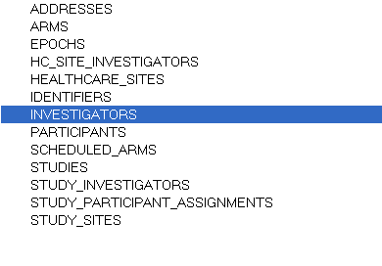

NOTE: | Security related tables (Dorian/CSM) reside in a different database and currently out of scope of this document

Populate Static Data
C3PR Application needs a predefined static data (like healthcare sites, addresses), for this the following static-data script must be run.

For Oracle
codebase\projects\core\db\oracle\static-data.sql
OR
codebase\projects\core\db\oracle\dummy-data.sql

For PostGreSQL
codebase\projects\core\db\PostGreSQL\static-data.sql
OR
codebase\projects\core\db\oracle\dummy-data.sql

NOTE: | Verify if the scripts have run well by checking the tables created. The following tables should be populate with data  Addresses, Healthcare_Sites (static-data.sql)  Addresses, Healthcare_Sites, Studies, Epochs, Arms, Identifiers, Study_Sites, Participants, Study_Participant_Assignments

Build / Deploy Code (Ant)
Perform the following steps to build your system.

Step | Action
1 | Open command prompt, change directory to codebase\antfiles  (Note – You can also use your your IDE’s built in Ant tool and skip the above test)
2 | Run the following ant task by executing the following command  Ant deploy-webapp

Ant messages display as each task is processing. The build-webapp task builds the core and web projects and deploys the software to the webapp directory of the web application server installation specified in the datasource.properties file.
This task accomplishes many tasks including generating and compiling the all the source files, deploying the files to CATALINA_HOME\webapps\c3pr directory

NOTE: | The default ant task build-all should be used with care. By default it is recommended not to use Globus/ESB/ServiceMix for testing basic Web applications. By running build-all, it attempts to build all the projects and might fail if the corresponding installations do not exist.  Refer this section for more details

Setup Web Server, Configuration
Make sure CATALINA_HOME environment variable as described in the previous sections.

Configure log4j
Update the logging info by modifying the following properties in
<CATALINA_HOME>\webapps\c3pr\WEB-INF\log4j.properties

log4j.appender.logfile.File=<CATALINA_HOME>/logs/c3pr.log
Use other log4j properties for debug/info as desired

 | BEFORE YOU BEGIN | For the below configurations, namely ESB Broadcast, ESB ConnectionFactory and Globus, It is recommended to set the ESB Broadcast to false if basic testing of C3PR is only desired, setting this to true makes it mandatory to install Service Mix, copy Globus certificates and build all projects in C3PR, detailed instructions of which is not included at this time.

Configure Dorian / Web SSO configuration
Set the Identity Provider Information, Identity Federation Service URLs in this file
<CATALINA_HOME>\webapps\c3pr\WEB-INF\applicationContext-web-sso.xml
Sample Settings maybe
<property name="idpUrl" value="https://localhost:8446/wsrf/services/cagrid/AuthenticationService"/>
<property name="ifsUrl" value="https://localhost:8443/wsrf/services/cagrid/Dorian"/>

 | BEFORE YOU BEGIN | For the below configurations, namely ESB Broadcast, ESB ConnectionFactory and Globus, It is recommended to set the ESB Broadcast to false if basic testing of C3PR is only desired, setting this to true makes it mandatory to install Service Mix, copy Globus certificates and build all projects in C3PR, detailed instructions of which is not included at this time.

Configure ESB Broadcast feature
ESB is used to broadcast messages from C3PR to other systems like Adverse Events Reporting System, Patient Study Calendar etc. Sometimes in development, testing environment it is necessary to have a feature to enable/disable this feature on demand. This can be set by updating the file

<CATALINA_HOME>\webapps\c3pr\WEB-INF\c3pr-servlet.xml

<property name="isBroadcastEnable" value="false" />

Configure ESB connection factory
If ServiceMix, Logic Fuse is installed and esb broadcast feature is desired, update the Active MQ Connection Factory settings in this file

<CATALINA_HOME>\webapps\c3pr\WEB-INF\applicationContext-esb.xml

<bean id="connectionFactory"
class="org.apache.activemq.ActiveMQConnectionFactory">
<property name="brokerURL" value="tcp://localhost:61616" />
</bean>

Configure Globus
Copy Globus certificates into your home directory from the following location of CVS repository
codebase\share\security\.globus
For Windows,
C:\Documents and Settings\<user-name>
For Unix,
/usr/home

Disable/Enable Login Screen
By default C3PR is disabled for Login/Security module, as most of this document highlights the disabling of Security/ESB/Service Mix option for basic Testing of C3PR. In case the user has installed servicemix, security, globus settings, enabling login is a matter modifying a couple of lines in the following file

workspace\projects\web\web\WEB-INF\c3pr-servlet.xml

For Disabling Login, comment the sections consisting of the bean ‘loginCheckInterceptor’.

<bean id="urlMappingName"
class="…..">
<property name="interceptors">
<list>
<!-- ref bean="loginCheckInterceptor"/-->
<ref bean="sectionInterceptor" />
</list>
</property>
</bean>
For enabling, uncomment the ref bean loginCheckInterceptor, wherever it occurs.

Running C3PR
Perform the following steps to run the system
Step | Action
1 | Open command prompt, change directory to <CATALINA_HOME>\bin
2 | Run the following command to start tomcat server  Catalina.bat
3 | After your web application server has completely finished starting, open Internet explorer 6 with the following URL  http://localhost:8080/c3pr/SearchAndRegister.do  C3PR home page should be displayed  The above URL is based on the fact that login is disabled as described in this section . If login is enabled, the home page can be requested directly as follows:-  http://localhost:8080/c3pr

NOTE: | Once the application is running, follow a series of workflows like  - Create a Default Study  - Register a Participant for Study (Create a new Participant)  For a detailed set of Steps to be followed above, refer the use cases document or contact support for individual step.

The following figure displays the browser window that opens with a successful system test.
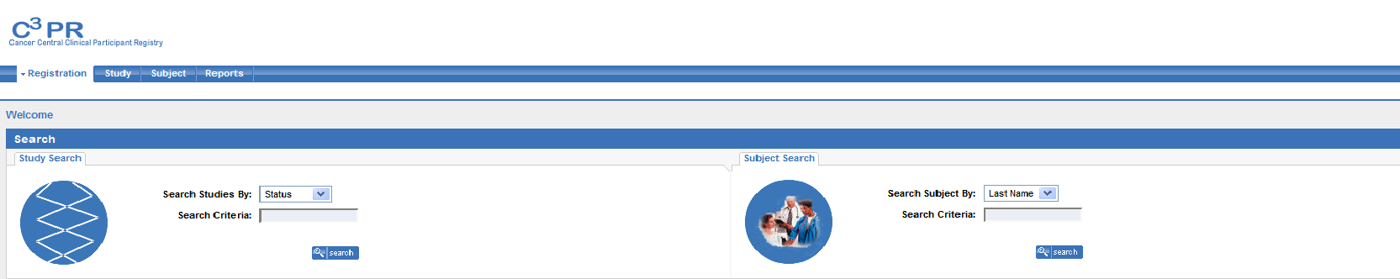

Summary of C3PR Components
C3PR Installation procedure includes the following components:
  - Source Code from gForge/cvs repository
  - Configuration files to enable you to customize your installation to meet your specific database, server, and other network needs
- database.properties
- applicationContext-esb.xml
- applicationContext-web-sso.xml
- c3pr-servlet.xml
  - DDL for creating tables in default schema (“C3PR”) – c3pr_ddl.sql
  - Static data / Dummy for populating sample data contents into schema – static-data.sql
  - Ant build file – build.xml

Contacting Technical Support
Please mail c3prv2-support@gforge.nci.nih.gov for support on Installation or general C3PR technical Support queries

Appendix - CVS

Setup Tortoise CVS client
There are 2 steps to this procedure.
First one is downloading and installing the TortoiseCVS wizard.
Second one is specifying the connection parameters and checking out c3prv2_elaboration_iteration3 from windows explorer.

Step 1: Downloading and installing TortoiseCVS.

(a) For Windows 95, 98, ME, NT, 2000, XP, and 2003, go to link http://www.tortoisecvs.org/download.shtml and click on the link - TortoiseCVS-1.8.30.exe to download it.

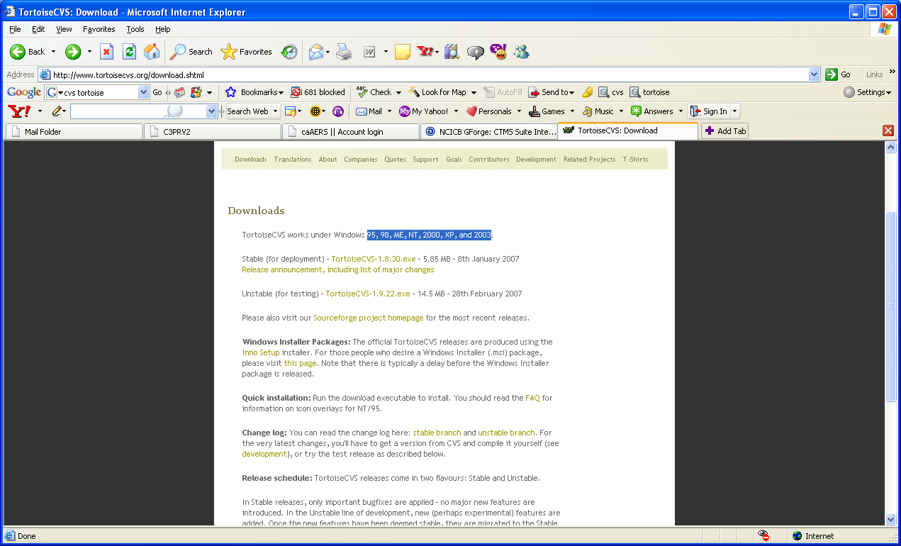

That link should take you to the following page
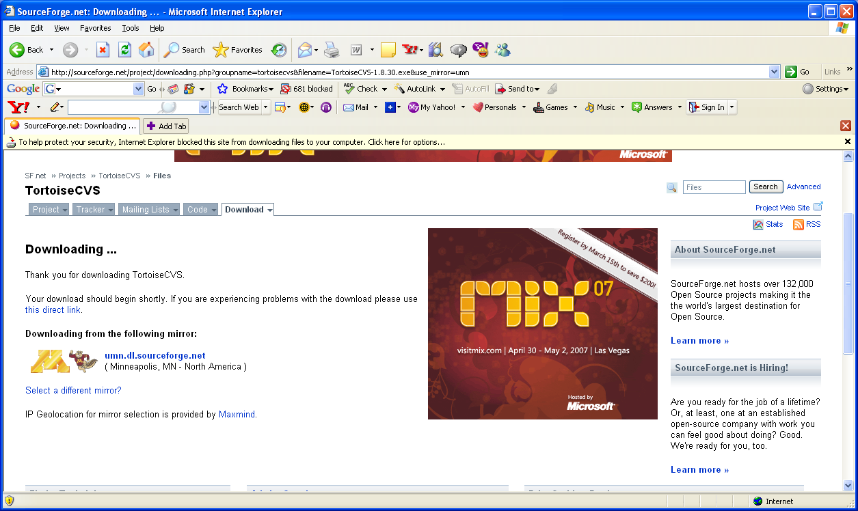

If you have the popup-blocker turned on, you may not be able to see the popup window to download the page. Then right click on the yellow bar, which says that windows blocked the popup as shown in the above image, and select download file. Or if you turn-off the pop-blocker temporarily, it enables you to see the following popup window.

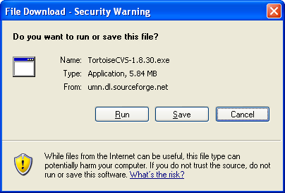

(b) Click-on save and select the destination folder, for example c:\ and save the TortoiseCVS-1.8.30.exe. Now navigate to the folder where you saved TortoiseCVS-1.8.30.exe, double-click on the .exe to run it. Select the language as English, then you should see
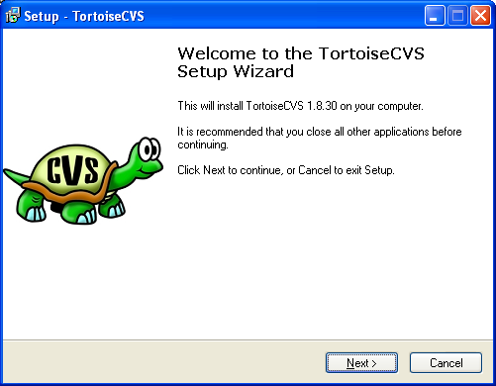

(c) Click on Next, and click on browse to select the destination folder to install TortoiseCVS, for example, c:\. Then the setup wizard would install the TortoiseCVS in C:\TortoiseCVS.

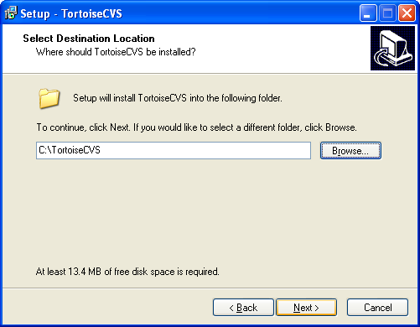

- Click on next. Select Full installation.
- Click on Next, the setup wizard will copy some files and prompt for you to restart the computer to complete the installation. You can select restart computer now or choose to restart it later.Save and close all other applications before restarting your computer. Click on Finish. This will restart your computer if you selected, restart now option.

- Restart your computer.

Step 2: Specifying the connection parameters and checking out the c3prv2_elaboration_iteration3 branch into your local folder.
(a) Once you restarted the computer, navigate to the folder, where you want to download the c3prv2 codebase, for example, c:\c3prv2.
(b) Right click on the folder and select CVS Checkout and you should see the following window.

(c) Under module tab type in (or select in case of protocol) the following values in the respective fields:

Select the Protocol as Secure shell(:ext)
Type in the field Server: cbiocvs2.nci.nih.gov
In the Repository folder field, type in: /share/content/gforge/c3prv2
Type in the User name field: anonymous
Type in the Module field: c3prv2

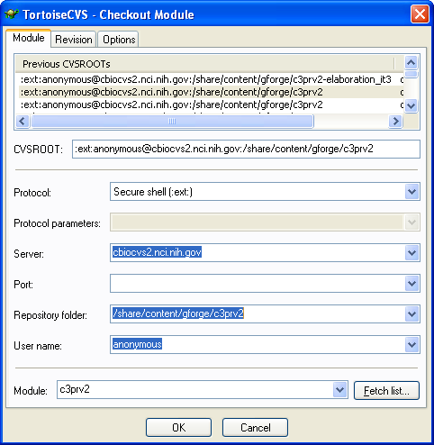

You can see the CVSROOT being automatically built as you enter each field.

Make sure there are no empty spaces or any other characters.

(d) Click on the revision tab. Under Revision tab click on the button, Choose branch or tag, and specify the branch or tag name as: c3prv2_elaboration_iteration3

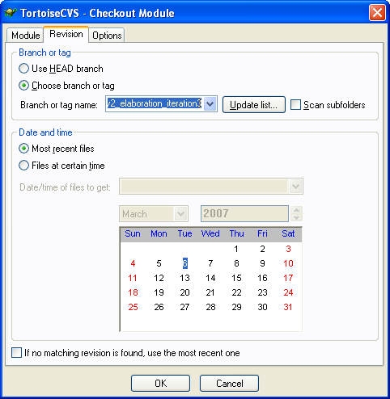

(e) Click on ok.
When it prompts for password, type anonymous

The TortoiseCVS wizard will start checking out the project in the folder you selected. In this case into c:\c3prv2. Wait for it to finish checking out. It may take a few minutes.

If you have successfully checked out c3prv2_elaboration_iteration3 , the tortoise will give a message that the download is complete. Click on ok to close the TortoiseCVS project checkout window. If for some reason the check out doesn’t start, or stops in the middle, check the connection parameters, network connection and repeat step 2 again.

You should have successfully checked out the c3prv2_elaboration_iteration3 from your explorer.

Setup Eclipse CVS Perspective
The following steps assume you are familiar with eclipse IDE as your development environment and you would like to use it’s cvs perspective to download files from cvs repository. If you don’t have eclipse IDE installed then it is recommended to use Tortoise CVS client as it is simple to setup and download

Step 1 – Got to Eclipse CVS Perspective by clicking on the menubar Window->Open Perspective-> CVS Perspective

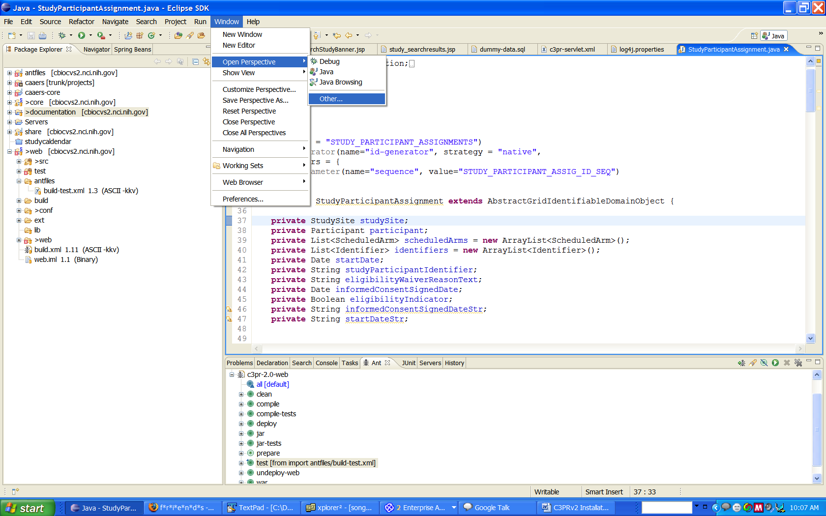
Step 2 – Create a new repository

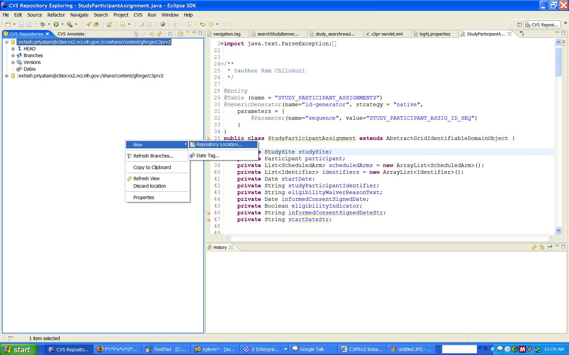
Step 3 – Enter the details for Repository location as follows. Enter Password as “anonymous”

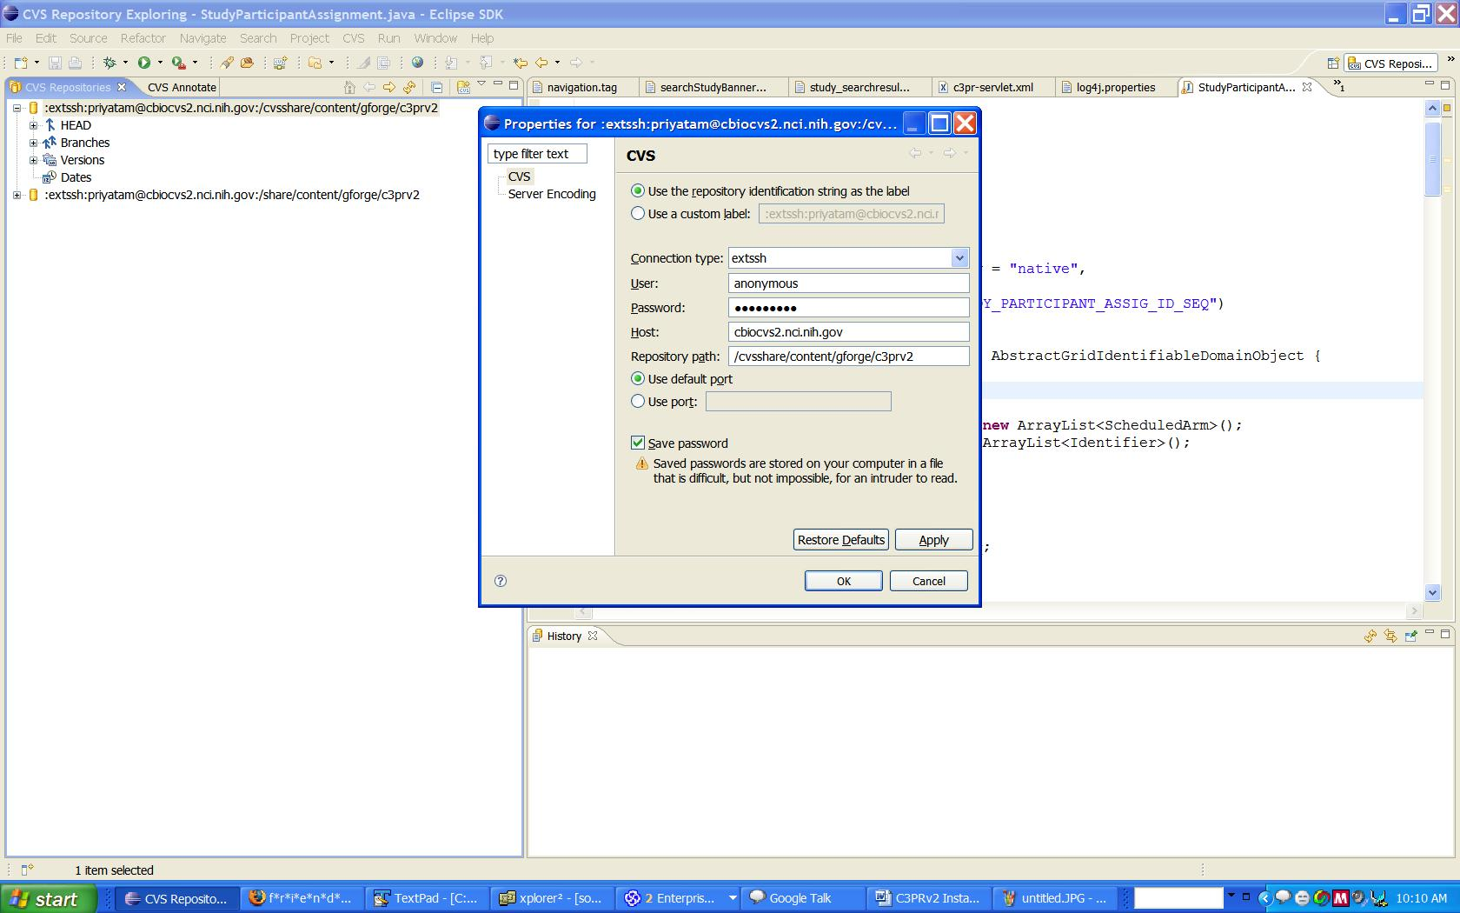

Step 4 – Refresh the Branches Section
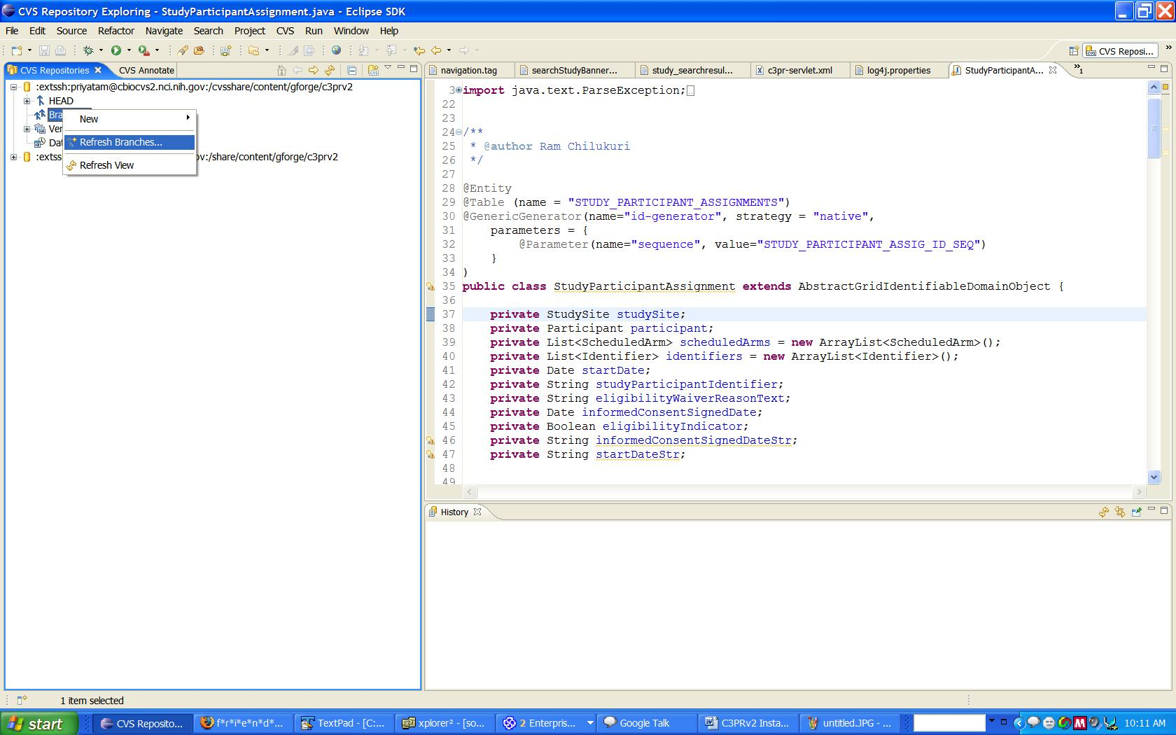

Step 5 – Deep Search for Tags in Branches
Once you click finish, you will get a dialog. Click on ‘deep search’ and wait till the process is completed (This might take some time to finish)
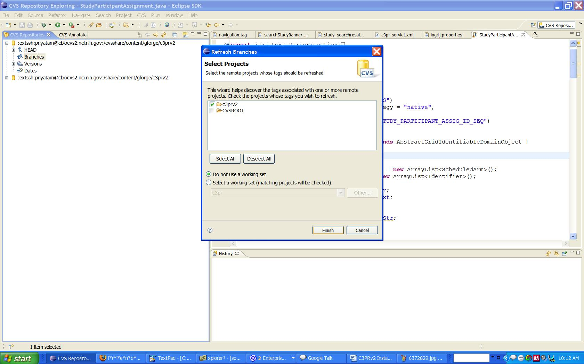

Step 6 – Once done, right click on the desired branch, checkout the entire ‘codebase’ folder

